

**Name- Yashas Gowda Ravi**

**Student ID- K2261873**

**Module Name- Consultancy in Practice**

**Module Code- BS7032**

**Business Consultancy Report (Element 2)**

**Type of Submission-Individual Written Report**

**Table of Content**

Executive summary………………………………………………………………………………………………………………3

Introduction………………………………………………………………………………………………………………………….4

Gibbs Reflection cycle……………………………………………………………………………………………….….………5

Description of the problem……………………………………………………………………………………………….….6

Feeling………………………………………………………………………………………………………………………………… 6

Evaluation…………………………………………………………………………………………………………………………….7

Analysis………………………………………………………………………………………………………………………………. 7

Conclusion……………………………………………………………………………………………………………………………8

Action Plan…………………………………………………………………………………………………………………………..9

Reference …………………………………………………………………………………………………………………………….9

**Executive Summary**

This reflective report summarises my experience working on a consulting project for McGraw Hill, a well-known innovator in the field of educational technology. It provides insights into the difficulties encountered and the priceless lessons discovered throughout this transformative experience.

The report begins by introducing McGraw Hill, a venerable organisation with a history of more than a century in the development of innovative educational solutions. The Gibbs Reflective Cycle is then used to explore the difficulties encountered during the consultancy assignment, particularly in the beginning.

The first stage involved thoroughly researching and analysing the state of educational technology. However, it was also characterised by issues with group communication and conflicts, which had an effect on output and morale.

The strategic focus is described in detail in the following sections of the report and focused on engagement strategies, localised content creation, and tailored approaches that were all in line with McGraw Hill's mission. Another important factor was the transition from dominant to democratic leadership styles.

In the conclusion, the transformative power of experiential learning is highlighted along with a plan of action for teamwork, communication, conflict resolution, and leadership development.

This reflective analysis, which emphasises the value of resilience, adaptability, and continuous learning while perfectly aligning with McGraw Hill's dedication to excellence and innovation in the educational technology sector, serves as a helpful benchmark for upcoming consultancy projects.

**Introduction**

In the world of educational technology and learning solutions, McGraw Hill, a name that is synonymous with excellence in education, is a mainstay. With a history spanning more than a century, McGraw Hill has been at the centre of revolutionising how students and teachers interact with educational materials.

Founded in 1888 by James H. McGraw and John A. Hill, the company's initial focus was on publishing educational materials and textbooks. Over the decades, it has evolved to meet the ever-changing needs of educational institutions, teachers, and learners. Today, McGraw Hill is a global educational powerhouse, committed to providing innovative, technology-driven solutions that enhance the learning experience for millions of students around the world.

In an ever-evolving world driven by technology and innovation, the educational technology sector has emerged as a dynamic and promising field. As I embark on my consultancy journey with McGraw Hill, a global leader in educational technology, I find myself drawn to the challenges and opportunities within this sector.

This report is a reflective exploration of my journey as I prepare for this consultancy project, seeking to understand the nuances, strategies, and key considerations required to navigate the educational technology landscape successfully in collaboration with McGraw Hill. It is a testament to my commitment to contributing meaningfully to the future of education and learning, leveraging the expertise and legacy of McGraw Hill to make a positive impact.

**Gibbs reflective cycle**

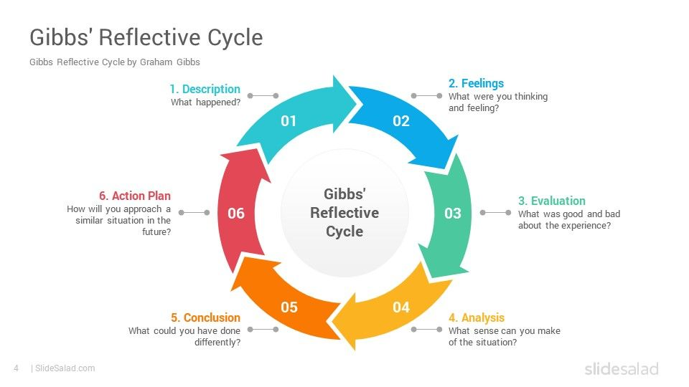

The Gibbs Reflective Cycle offers a structured framework for examining experiences, facilitating learning, and informing future actions. In this reflective analysis, I will employ the Gibbs Reflective Cycle to explore my journey in a consultancy assignment with McGraw Hill, focusing on the challenges faced while navigating the educational technology landscape. This journey involved understanding the sector, selecting a strategic focus, building a robust strategy, and adapting leadership styles. Each stage presented unique challenges, conflicts, and learning opportunities.

**Description**

The initial phase of my consultancy project represented a crucial foundation in our journey with McGraw Hill. This phase was dedicated to immersing ourselves in the intricacies of the educational technology landscape. It required extensive research, in-depth analysis of market trends, and a profound understanding of the multifaceted nature of the sector. My primary responsibility during this phase was to ensure that I acquired a comprehensive grasp of the educational technology field. This understanding would ultimately play a pivotal role in aligning our strategies with the overarching vision of McGraw Hill.

Nonetheless, this phase was not devoid of its set of challenges, one of the most notable being the intricacies of working effectively within a group. The group dynamic presented its own set of complexities. Poor communication channels, frequent misunderstandings, and occasional disputes within the team acted as significant roadblocks to our progress. These obstacles were further exacerbated by personal issues that crept into our collaborative efforts, coupled with differences in our individual working styles. Together, these factors created an environment that was less than conducive to fostering effective collaboration.

**Feelings**

Initially, I embarked on this consultancy project with a sense of enthusiasm and anticipation. The prospect of engaging in the development of innovative educational technology solutions, particularly in partnership with a distinguished institution like McGraw Hill, was undeniably thrilling and presented an invigorating challenge. The vision of contributing to the evolution of the education sector through technology-driven initiatives was a motivating force.

However, as we delved deeper into the project and commenced our collaborative efforts within the group, a series of unforeseen challenges emerged. Communication barriers proved to be a formidable obstacle, hindering the seamless exchange of ideas and information. Additionally, conflicts within the group began to surface, leading to tension and discord. This unexpected turn of events began to chip away at the initial enthusiasm I had harboured. Frustration and disappointment gradually set in as our collective productivity failed to meet the lofty expectations we had set at the project's outset. The disparity between our initial anticipation and the reality we were facing was palpable and required a thoughtful approach to overcome.

**Evaluation**

The educational technology landscape is a dynamic and multifaceted field with ever-evolving trends and challenges. Market trends such as personalized learning, digital content, and adaptive platforms are gaining prominence, but they coexist with significant challenges. These challenges include intense competition, integration complexities, pricing strategy intricacies, and the crucial need for localization. Understanding these trends and challenges was vital in shaping our strategic thinking and aligning our approach with McGraw Hill's mission.

Despite the conflict and challenges we faced during this phase, it was also a period of tremendous learning. The conflict highlighted the significance of effective communication and collaboration within a team. It underscored the need for open dialogue, active listening, and conflict resolution skills. The conflict, though initially disheartening, became a catalyst for growth and development as we collectively worked towards resolution.

**Analysis**

Reflecting on the conflict and communication issues, it becomes evident that these challenges were the result of a confluence of several factors. First and foremost, the diverse backgrounds, perspectives, and experiences of team members naturally led to different communication styles and varying expectations regarding the exchange of information. These differences, while potentially enriching, were exacerbated by the absence of clear and established communication protocols within the team, leaving room for misunderstandings and misinterpretations.

Secondly, external personal issues that some team members were grappling with inevitably seeped into our collaborative interactions. These personal challenges, ranging from time constraints to individual stressors, created an additional layer of complexity that hindered our ability to function cohesively.

Moreover, the dominant leadership styles exhibited by certain team members were instrumental in catalysing the conflicts we encountered. A subset of team members embraced an autocratic leadership approach, wherein decision-making authority was concentrated in the hands of a few. This centralized decision-making process not only created bottlenecks but also stifled the creative potential of the team. The prevalence of such a dominant leadership style engendered an inherent imbalance within the team dynamics, detrimentally impacting morale and overall productivity. This power imbalance became a focal point for the conflicts that arose, necessitating a recalibration of our approach.

**Conclusion**

In conclusion, the challenges faced during the initial phase of our consultancy project with McGraw Hill were instrumental in shaping our learning journey. While the conflict and communication issues initially posed significant hurdles, they ultimately served as catalysts for personal and professional growth. These challenges highlighted the importance of effective communication, conflict resolution, and adaptive leadership in collaborative work environments.

In this consultancy project with McGraw Hill, I embarked on a transformative journey through the educational technology landscape. It unveiled the sector's intricacies and challenges, guiding my collaboration with McGraw Hill effectively. Despite initial difficulties, including communication gaps and conflicts within the team, these experiences shaped my personal and professional growth.

Understanding the educational technology sector laid the groundwork, emphasizing trends and challenges. The identification of market opportunities, informed by a SWOT analysis, led us to focus on tailored strategies aligned with McGraw Hill's vision. This phase also highlighted the importance of localization and the role of collaborative banking strategies in pricing and expenditure allocation alongside McGraw Hill.

The strategy-building phase prioritized localized content creation and engagement strategies, including webinars and partnerships. Collaborative banking strategies reinforced the significance of financial considerations in our approach. The adaptation of leadership styles, shifting from dominance to democracy, fostered improved collaboration and client-centric outcomes, in harmony with McGraw Hill's ethos.

My action plan integrates these lessons, emphasizing enhanced communication, conflict resolution, adaptive leadership, and team building. This reflective analysis underscores the transformative power of experiential learning and the potential for challenges to drive growth. Armed with this knowledge and commitment to continuous improvement, I am well-equipped for future consultancy projects, aligning seamlessly with McGraw Hill's pursuit of excellence in the educational technology industry.

**Action Plan**

Moving forward, I have developed a clear action plan to address these challenges and enhance my skills:

**Enhancing Communication Skills:** I will focus on improving my communication skills, including active listening, clear articulation, and providing constructive feedback. This will facilitate smoother interactions within the team.

**Conflict Resolution:** I will invest time in developing conflict resolution strategies to address disputes effectively and ensure that conflicts do not hinder our progress.

**Adaptive Leadership:** As a result of my awareness of how different leadership philosophies affect team dynamics, I will make an effort to modify my style of leadership to suit the demands of the team and the project. This adaptability will promote a more welcoming and cooperative workplace.

**Team Building:** I will actively engage in team-building activities to strengthen interpersonal relationships and create a cohesive and harmonious team.

**Personal Growth:** This experience has made it clearer than ever how crucial personal development and self-awareness are. I'll keep making investments in my personal growth to give myself the best chance of successfully navigating difficulties and conflicts in upcoming projects.

I am confident that by carrying out this action plan, I will be better equipped to negotiate the complexities of the educational technology landscape and effectively contribute to future consulting assignments, in line with McGraw Hill's dedication to excellence and innovation.

**References**

Hammer, G.D., McPhee, S.J. and Education, M.H. eds., 2014. Pathophysiology of disease: an introduction to clinical medicine (p. 784). New York: McGraw-Hill Education Medical.

Husebø, S.E., O'Regan, S. and Nestel, D., 2015. Reflective practice and its role in simulation. Clinical Simulation in Nursing, 11(8), pp.368-375.

Sibson, L., 2008. An introduction to reflective practice. Journal of Paramedic Practice, 1(3), pp.121-125.

Prinz, W., 1997. Perception and action planning. European journal of cognitive psychology, 9(2), pp.129-154.